Republic Polytechnic

A101 Science

Worksheet 02: Strange Actions

- List down the steps that you would take to examine phenomena such as those shown in the programs for today’s problem.
- Examine one program at a time.
- Record observations made when various parameters are changed in the program.
- …

Program1.exe

- Let us start by exploring the first program, Program1.exe.

- In Program1.exe, we have the following objects.
Object GB (“gold” at one end and “blue” at the other end)

Object NGB (no “gold” or “blue” ends)

- Now let us note down the various observations when different objects in Program1.exe are selected.
Object type selected | Observations
No object
NGB
GB

- From your observations above, what is the purpose of the yellow box? Can you suggest anything about the behaviour of the yellow box and the objects?
- What do you think the arrow (in the yellow box) is indicating?

- Imagine that there is another object which we can refer to as “BG”. What do you think will be the behaviour on the yellow box when object BG is present instead of GB?

Program2.exe

- Let us now move on to examine Program2.exe.
- Instead of objects GB and NGB, we now have the following objects:
 | AU (arrow pointing up) |  | AD (arrow pointing down)
 | Connecting line |  | Object S
 | Connecting line |  | Detector (This detects the direction of something “flowing” through the connecting lines)

- In the table below, record your observations when the different objects are selected:
Object type selected | Observations
No object
AU
AD

- Based on your observations of Program2.exe, what could have caused the “flow”?
- What similarities and differences do you observe when AU is selected as compared to when AD is selected?
- What do you observe about the behaviour of the yellow box when it is taken near S in the
  - absence of AU and AD?
  - presence of AU?
  - presence of AD?
- From the behaviour of the yellow box, what can you say about the behaviour of S when
- AU and AD are absent?
- AU is present?

- AD is present?
(Hint: Does S behave in a similar way to GB or BG?)
- In general, when S behaves like GB, what does the Detector show? When S behaves like BG, what does the Detector show?

Program3.exe

- Now let us study Program3.exe using object GB for a start.
- Systematically note down the observations involving all the possible scenarios for object GB in the table below:
Object type | Starting Position/speed | Observations
GB | A/stationary
GB | B/stationary
GB | A/slow
GB | B/slow
GB | …
GB | …
GB | …

- What do you observe about the Detector when the object GB is stationary at any of the points A, B, C or D?
- What do you observe whenever the object GB is being moved?
- How does the speed of the movement of object GB affect the Detector? What does this suggest about the flow through the Detector?
- When GB is being moved from A to B,
- Which side of the Detector shows a change?
- In which scenario (i.e. when No object/AU/AD is selected) in Program2.exe did you make a similar observation about the Detector?
- Hence, with the help of Program1.exe, determine whether S is behaving like NGB, GB or BG.

- Complete the table below for the different possible combinations in Program3.exe for the object GB.
*
Table 1. Summary of Program3.exe
Object type | Direction of movement | Equivalent scenario in Program2.exe | Behaviour of S (similar to NGB/GB/BG)
GB | A B | AD is selected | BG
GB | A B
… | …
… | …
… | …

- Repeat parts (a), (e) and (f) for the objects NGB and BG.
*

- Summarise the similarities and differences between the three programs. Hence, relate the individual conclusions you have drawn thus far among Program1.exe, Program2.exe and Program3.exe.

Another behaviour of GB and BG

- It has been found that repulsion between two objects occur when the similar ends of both objects are placed close together. On the other hand, attraction occurs when the ends of both objects are different. B-ends repel other B ends but attract G-ends. Similarly, G ends repel G-ends but attract B-ends.
Table 2. Repulsion and Attraction
Repulsion | Attraction
 | 
 | 

Making predictions

- For the set-up given in Program3.exe,
- When object GB is being moved from point A to B, should it experience a push or a pull due to S? Give reason(s) for your answer. [Hint: Refer to Q4e]
- When GB is moved from point B to A, should it experience a push or a pull due to S? Give reason(s) for your answer.
- Similarly, when GB is moved from point C to D, should it experience a push or a pull due to S? Give reason(s) for your answer.

- Now, assume that we have a set-up as shown below.
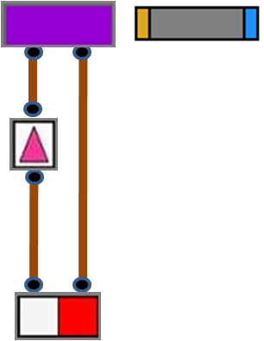

Figure 1. Interaction of GB with set-up
- If GB is placed close to S as shown in the diagram, should GB experience a push or a pull? Explain your answer.
- If AU is replaced by AD, should GB experience a push or a pull? Explain your answer.
- If GB is replaced by BG in the figure above, should BG experience a push or a pull? Give reason(s) for your answer.

- Two AU are connected in the manner shown in the set-up below.
*

?
?
Figure 2. Set-up of two AU
- What do you think the Detector will show?
- What do you think will be observed when you move the yellow box near S?

- In the set-up given below, two identical objects GB are placed at positions A and D which are equidistant from object S. At a certain point in time, GB at position A is moved towards B while GB is moved from D to C at the same speed.
*
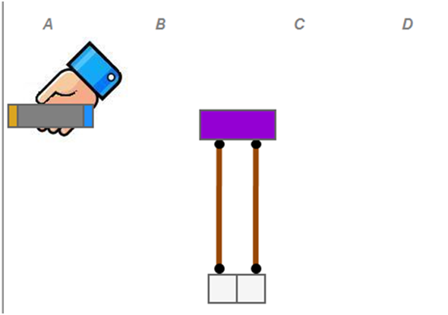
Figure 3. Movement of two GB objects towards S
- What do you think the Detector will show during this process?
- What would the Detector show if we repeat the experiment but object GB at position A is moved with a faster speed?
- For the different cases described below, fill up the table with the predicted behaviour of the Detector and your reason(s) for the answer. (Assume that the objects on the left and right move at the same speed in all cases.)

Table 3. Predicted behaviour of the Detector
Object on the left | Direction of movement | Object on the right | Direction of movement | Predicted behaviour of Detector | Reason(s) for your prediction
GB | AB | GB | CD
BG | AB | BG | CD
BG | AB | BG | CD
BG | AB | GB | CD
BG | AB | GB | CD

Going Further

- Use the objects encountered in the three programs or otherwise, suggest possible set-up(s) that can achieve each of the following outcomes and explain why they are able to do so.
- The detector in Program3.exe shows a stronger signal without using more GB
objects.
- Move object BG in a certain direction without physically pushing it.
- The speed of object BG in part (b) is increased.
- The two sides of the detector lights up alternately in a continuous manner.

